1. Log in to the <https://skill-search.topcoder-dev.com/>
2. Click on the edit talent

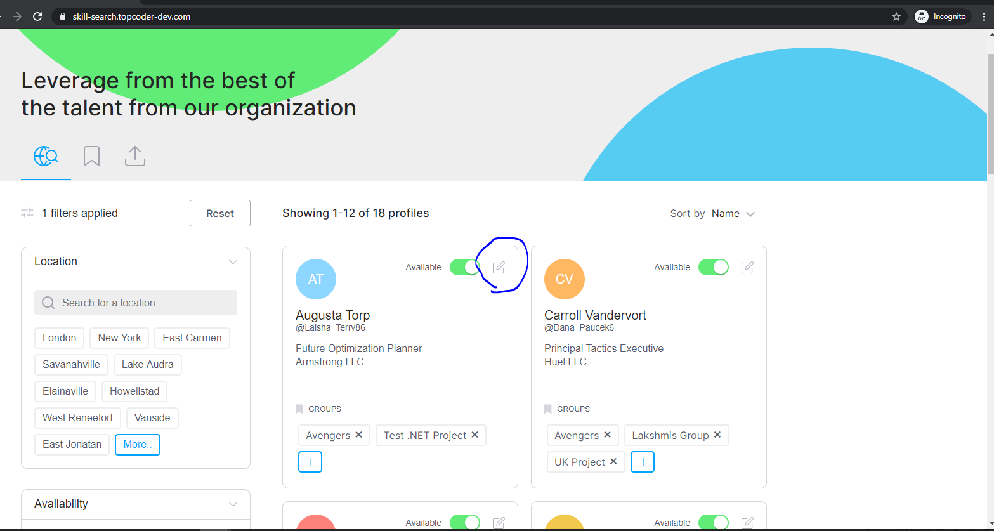

1. Alignment on groups is not correct

