1. Log in to <https://skill-search.topcoder-dev.com/>

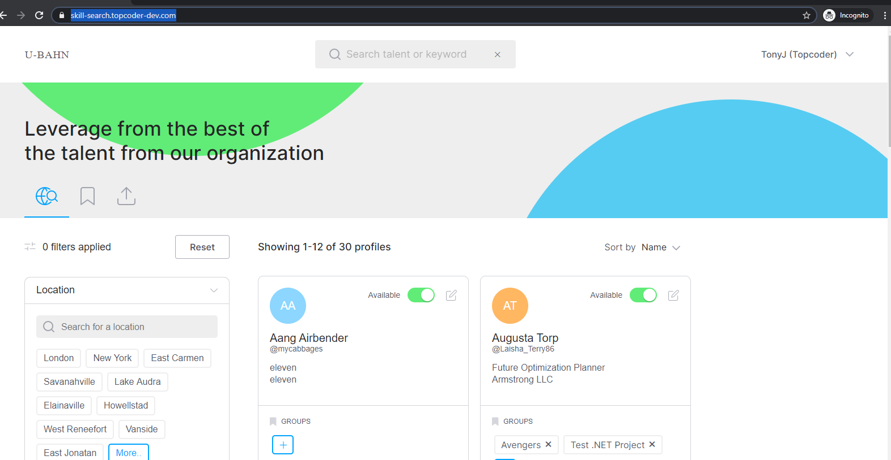

1. Edit pop up is not loaded correctly. Alignment at the top is not correct.

